Cassville FFA Meeting Agenda

1. **Opening Ceremonies - 7 PM**
2. **Old Business (talk about how it went)**
   1. FFA Week
      1. Dress Up Days
      2. Activities
      3. Alumni Breakfast
      4. Staff Breakfast/Appreciation
      5. Decorations
   2. LDE’s
3. **New Business**
   1. Treasurer’s Report
   2. UW-Platteville CDEs (NO D/Fs in ANY classes or you can’t go!)
      1. March 21: 7 AM-3PM
      2. Any interest in being an alternate, talk to Mrs. Henry
   3. Degree Applications
      1. Discovery
      2. Greenhand
      3. Chapter
      4. State
      5. American
   4. FFA Banquet
      1. April 7 6:00 PM-8:30 PM
      2. Taco Bar
         * FFA provides taco meat, chips/shells, and toppings
           1. Volunteers

Side Dish #1 Volunteer: FRUIT -Riedl Insurance

Side Dish #2 Volunteer:

Side Dish #3 Volunteer:

Side Dish #4 Volunteer:

Regular Milk:

Regular Milk:

Chocolate Milk:

Chocolate Milk:

Punch: Riedl Insurance

Water:

Dessert: Retallicks CAKE

* + 1. Official Dress Required for Officers (officers pick a job)
       - 50/50 Raffle for Greenhouse Coupon
       - Member sign-in
       - Guest sign-in
    2. Members-Wear FFA Colors/Shirts
    3. Edit Script (All Officers can help with this!)
    4. Clean-Up Crew After Banquet (all old officers and any volunteers looking for hours)

Cleaning dishes/utensils/roasters

Tearing down decor

Leftover food in containers & fridge

Garbages to dumpster

Re-set cafeteria

Empty coolers and bring extra items up to ag room

* + 1. FFA Apparel for next year will be online and hopefully available starting April 1
       - Design Idea that won
       - 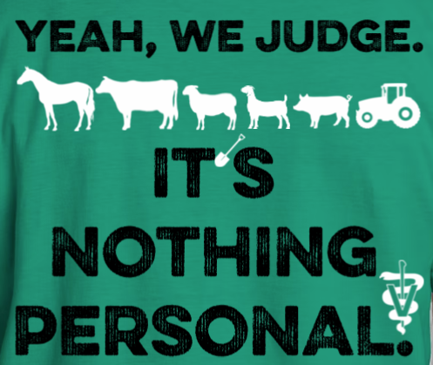Back
       - Front left side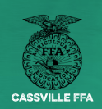
       - Any Embroidery items if the company is able to do this design
       - 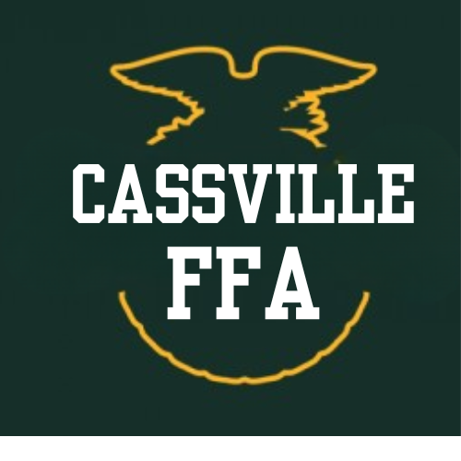
  1. FFA Scrapbook
     1. Pictures printed please DONT FORGET MRS H

1. **Other Business?**
2. **Closing Ceremonies**
3. **PIZZA & BINGO!!**

**Attendance :**